SOFT8026 - Data-driven Microservices
Assignment 1 Form

Instructions
Please complete the following form and include in the zip file you submit. Include screenshots / images in the appendices below the form.

Brief discussion of your architecture – why the microservices you chose, what messages are you passing between them? | The Redis, Flask and TweetAnalytics.py are my 3 microservices. I built a container to stream tweets using redis and flask.
Briefly discuss how far you got with the following functional requirements:
1. Reading and streaming of  the tweet data | I could read but not stream the tweet data.
2. Data analysis; what analytics / metrics did you calculate? | Longest and shortest tweet length.
3. Web page with list or summary of analytics / metrics | I built images with weblogs.dockerfile to allow for locahost but no analytics.
Checklist:
I used gRPC | Y/N Y
I used streaming with gRPC | Y/N N
I built docker images using Dockerfiles | Y/N Y
I orchestrated my application using Docker Compose and a YAML file | Y/N Y
Any other comments? | I attempted to integrate grpc streaming but I just couldn’t get anything to work. I also had to create a new VM as my original one ran out of storage.

Appendix A – Your Architecture Sketch / Diagram

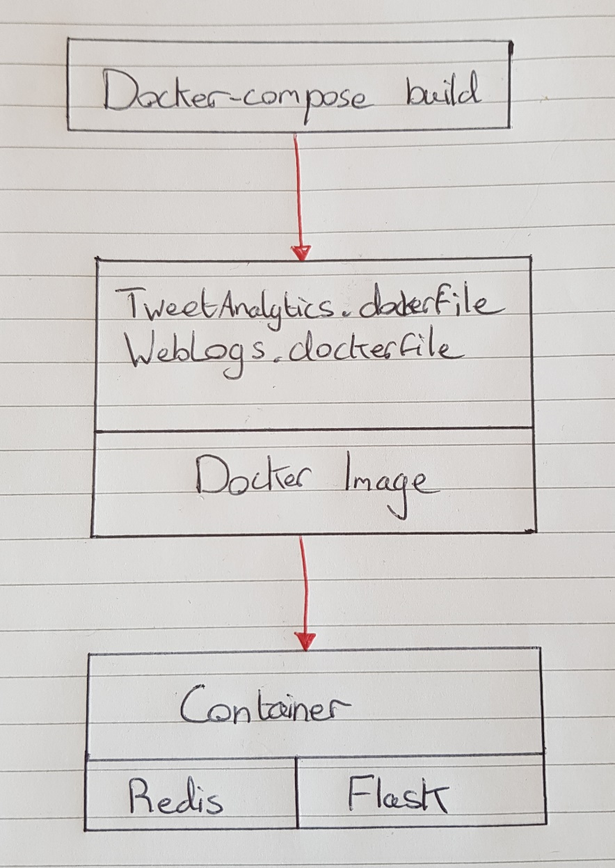

Appendix B – Output from a sample run

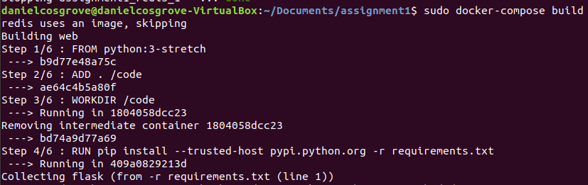
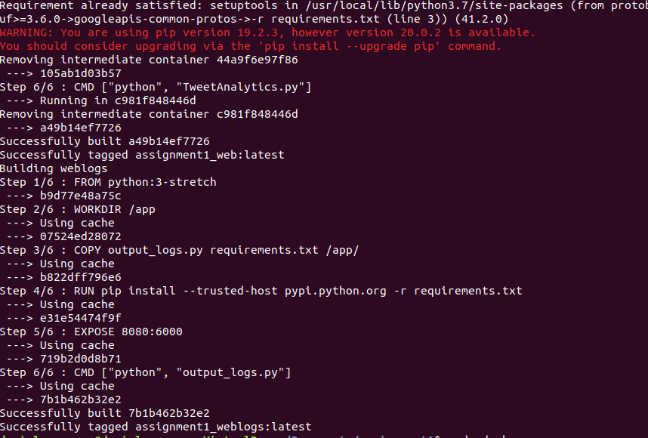
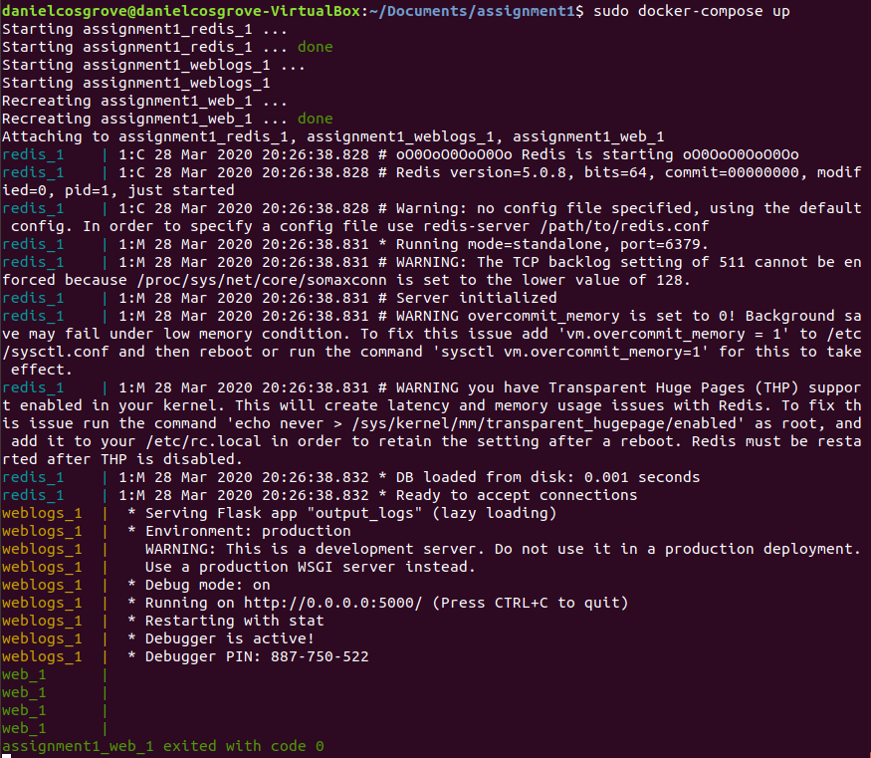

Appendix C – Screenshot from web page

